**LTJ ISKRA 2  
Installation instructions and user’s manual**

Contents:

1. What is Iskra 2? 1

2. Description 1

3. Installation instructions 1

4. Technical information 2

5. User’s manual 3

6. Special thanks 5

# 1. What is Iskra 2?

HI! Szikaka (and Ciarence, I’m just passing through) here, presenting a new modded gun for Receiver 2:

**LTJ Industries Iskra 2 bolt-action rifle (2.0 version)**

It’s a “remake” of the remake of the classic Iskra, the first working gun modded into the game and it comes with a substantial list of improvements, including an integrated box magazine and a variety of sight options. The second remake includes a better scope shader, as well as making it compatible with the newest modding kit release :)

# 2. Description

A modded bolt-action rifle

An intermediate caliber hunting rifle. Repurposed by LTJ Industries for post-mindkill use, it comes with a rail for mounting various attachments. While not originally designed for anti-robot use, a 5.56 caliber bullet can punch through hog's skull; a glorified computer case would be an afterthought.

# 3. Installation instructions

**Use R2modMan**

# 4. Technical information

Caliber – 5.56 NATO, standard round

Feeding – Internal box magazine, 6 rounds

Point of impact – Top of the front sight for ironsights  
 – Center of the reticle for the scope

Armor piercing – Yes

# 5. User’s manual

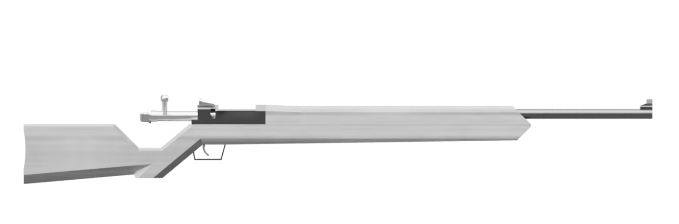  
**E** – Open bolt. The chambered round will be automatically ejected

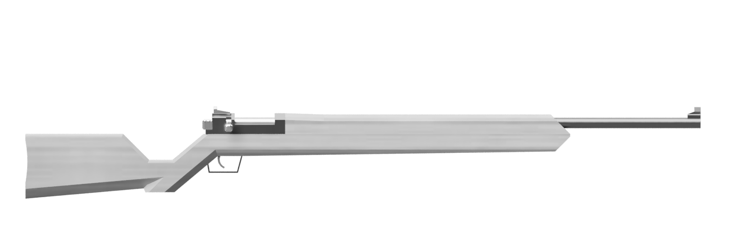**R** – Close bolt. If available, the next round will be loaded from the magazine

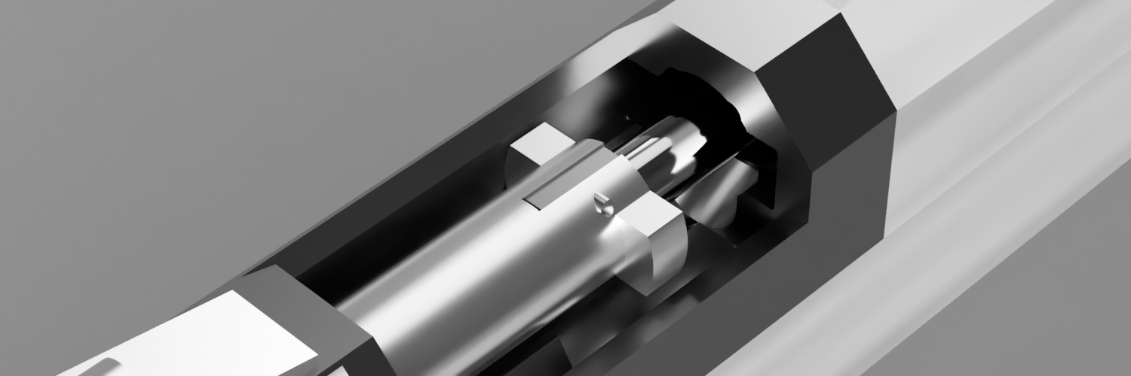  
**R + T** – Press check. The striker will be recocked by doing it

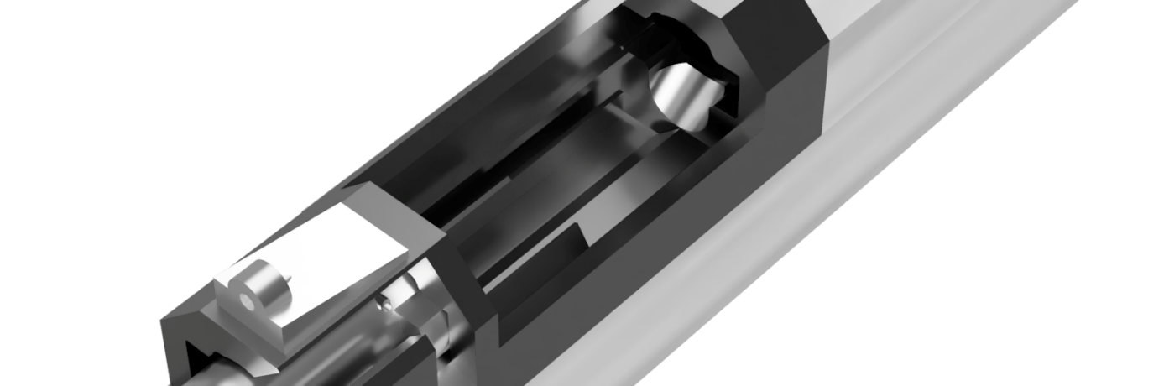  
**Z** – Load rounds into the magazine

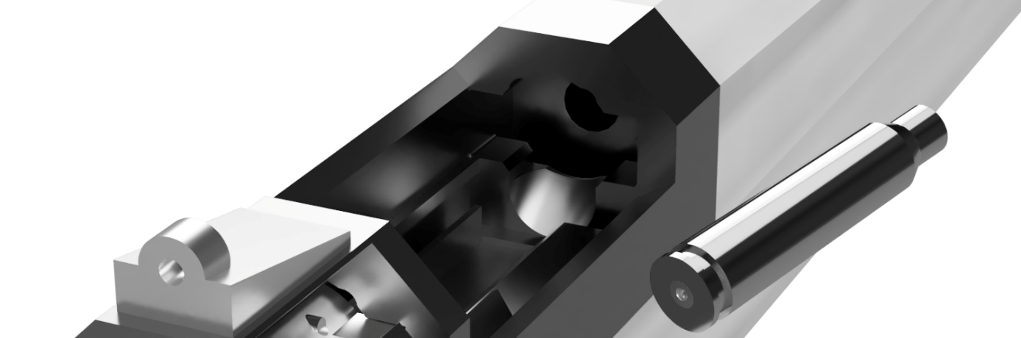  
**G** while ejecting – Catch the ejected round and add it to the inventory  
**Z** while ejecting – Load the extracted round back into the magazine

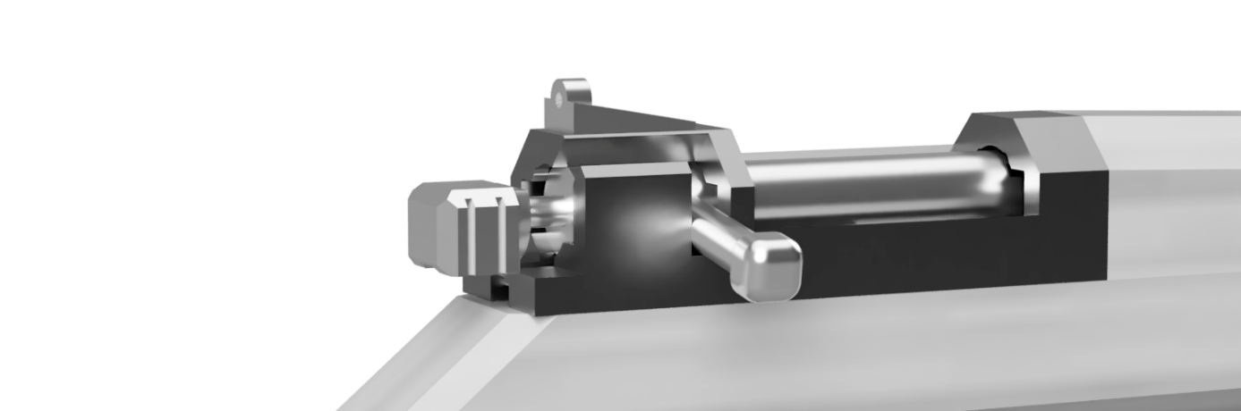  
**F** – Cock the striker

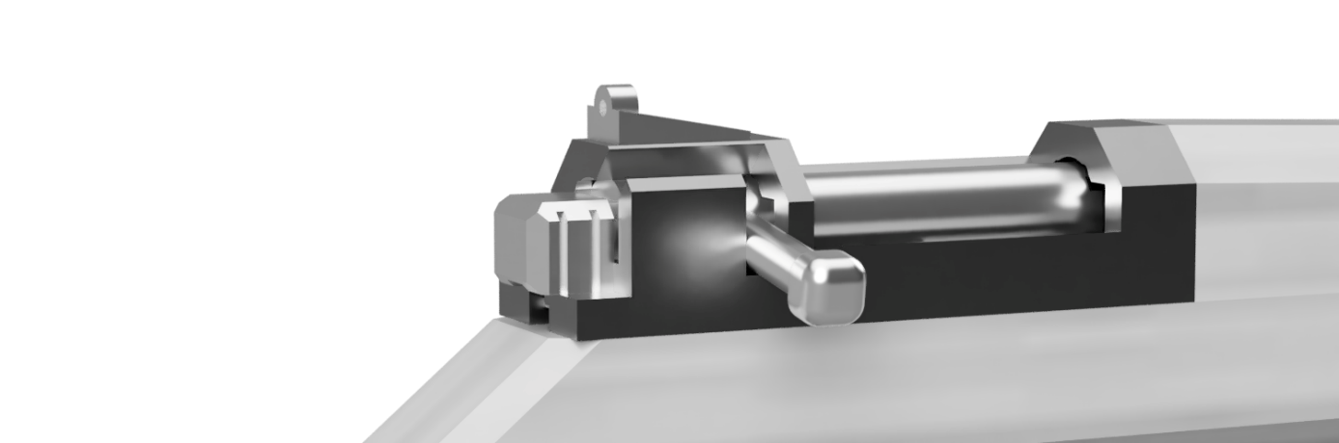  
**LMB + F** – Decock the striker. This will make the rifle safe to *“holster”*

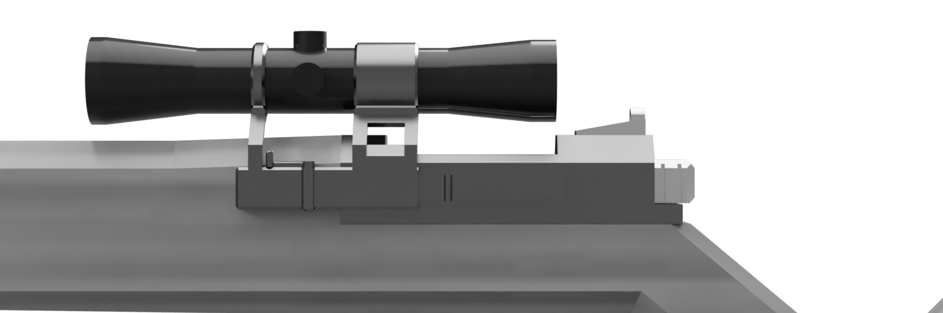

**Sight change** – To change the sights you can either edit the plugin’s configuration file (Receiver 2/BepInEx/config/Iskra2Patch.cfg) or use [BepInEx Configuration Manager](https://github.com/BepInEx/BepInEx.ConfigurationManager) to change it in-game.

**Options**:

* Rear aperture sight – Good field of vision but only moderately precise
* Notch sight – More precise than the aperture but target acquisition is harder
* Scope – Variable magnification scope. Most precise option sacrificing a lot of FOV. Change magnification with the mouse wheel

# 6. Special thanks

**Heloft** – sounds extracted from Verdun

**Ciarence** – 2.0 version

[**VAZGRIZ**](https://vazgriz.com/158/reflex-sight-shader-in-unity3d/) – Scope shader

**Wolfire Games** – ♥